Create a React Application named “cricketapp” with the following components:

* ListofPlayers
* IndianPlayers

**ListofPlayers.js**

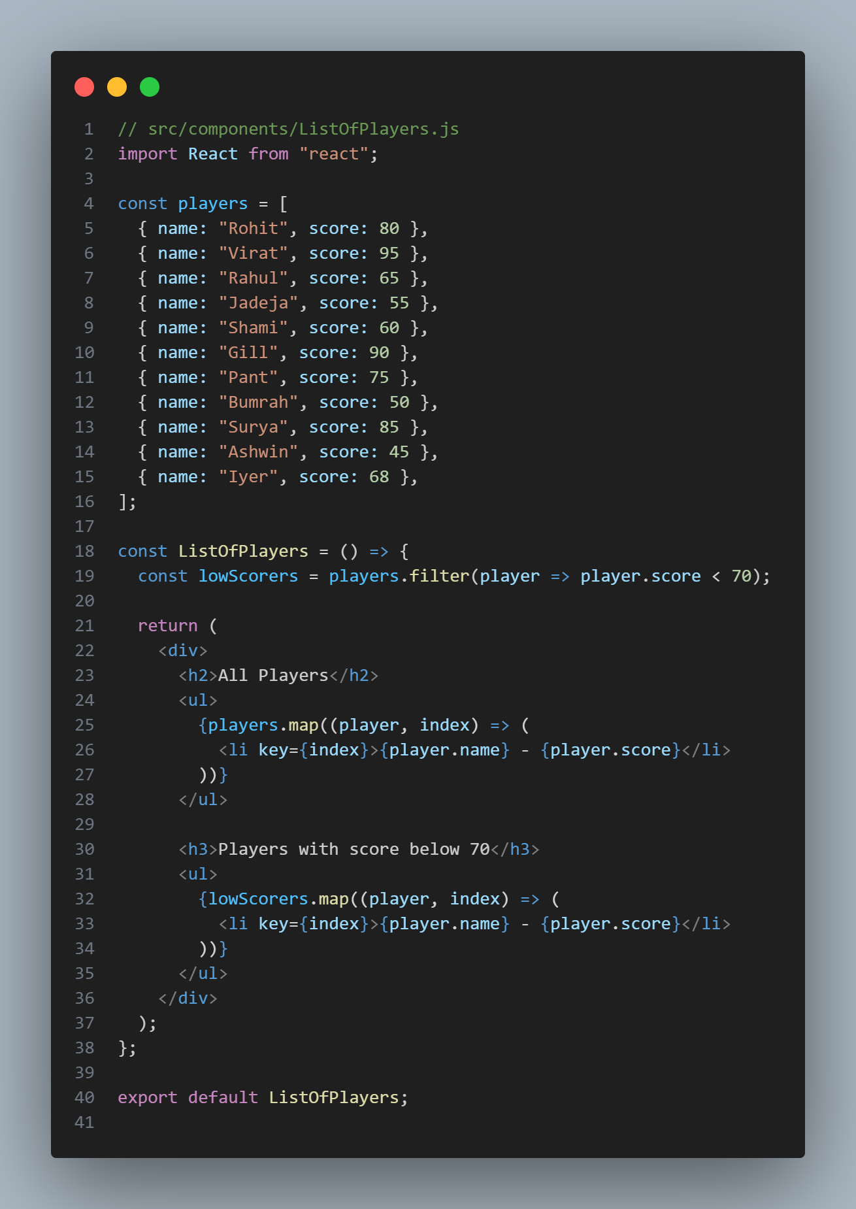

**IndianPlayers.js**

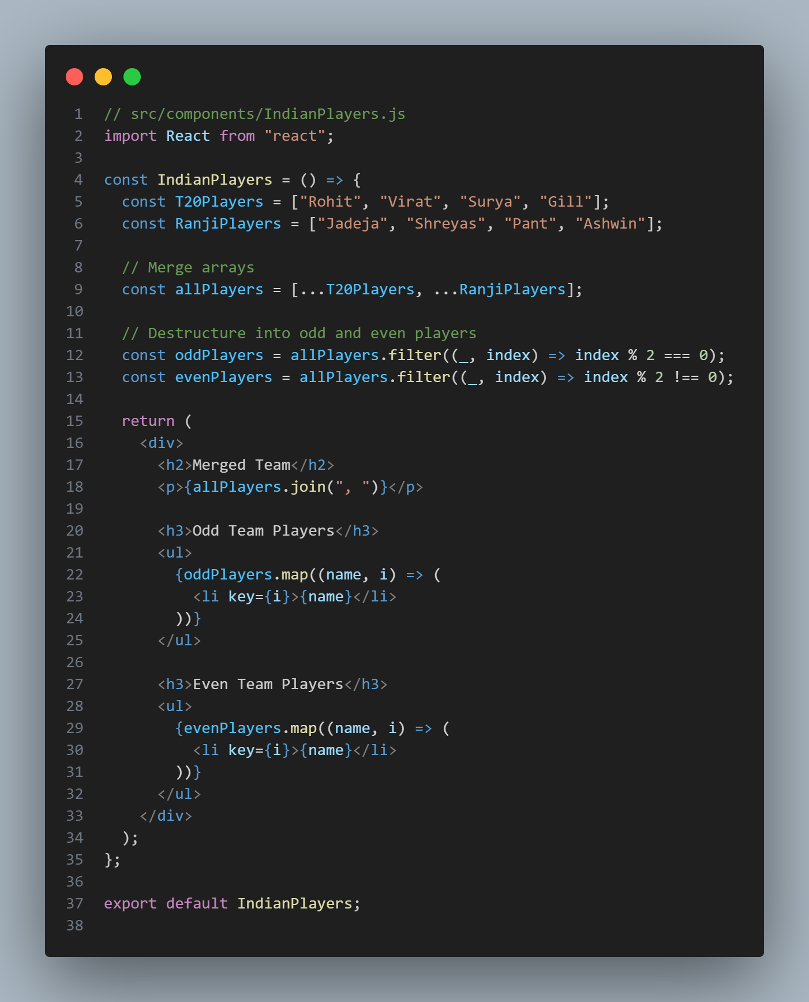

**App.js**

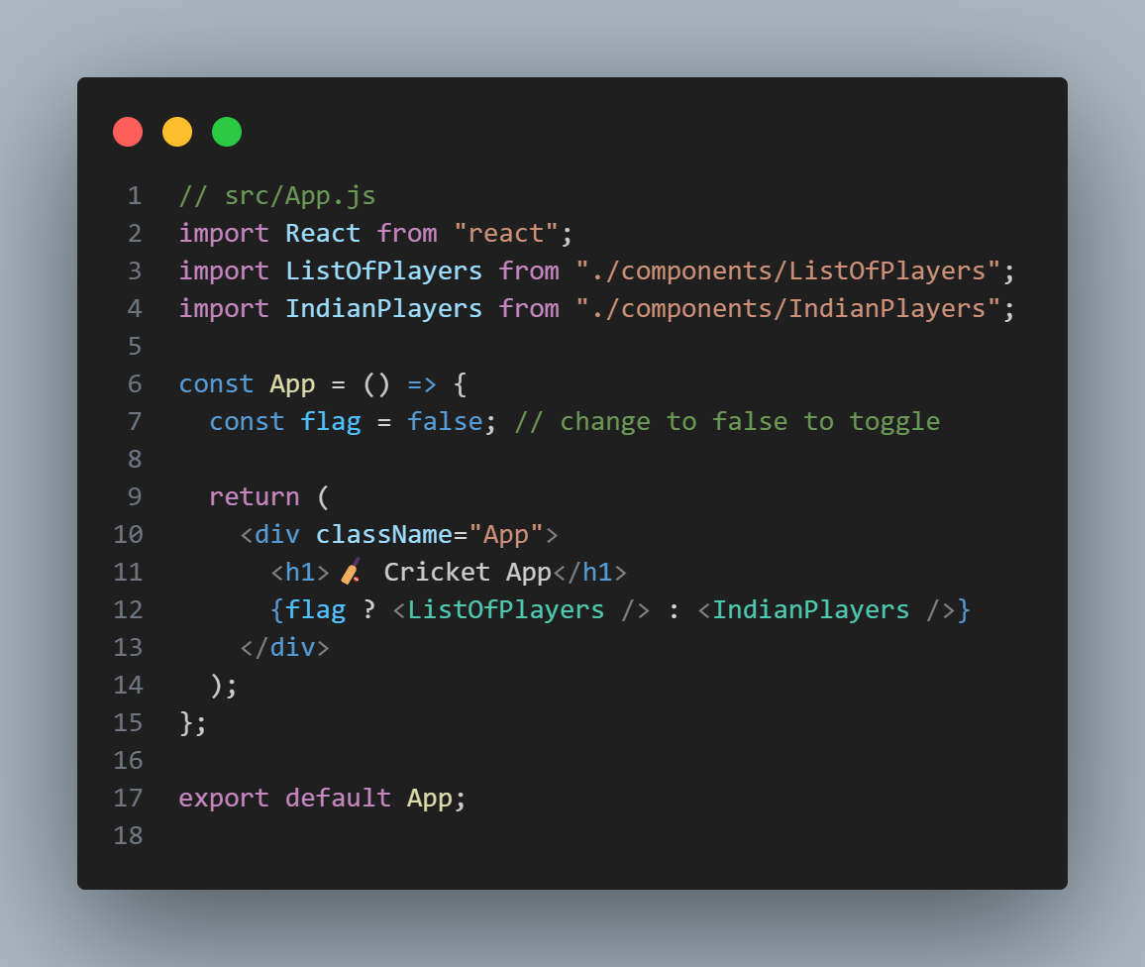

**OUTPUT**

When Flag=true

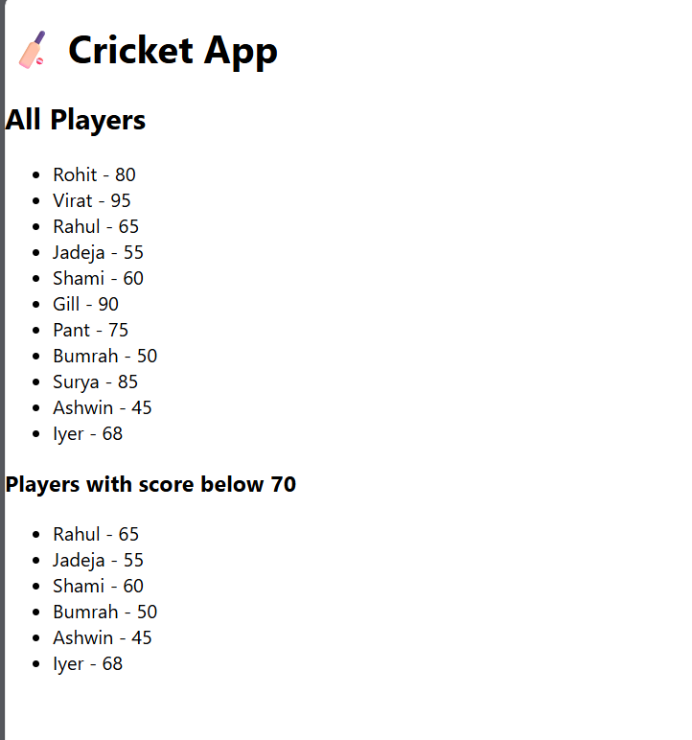

When Flag=false

